Format of Question paper for Comprehensive Test

Birla Institute of Technology & Science, Pilani
Work Integrated Learning Programmes Division
Second Semester 2020-2021
Mid-Semester Test
(EC-3 Makeup)

SOLUTION

Course No. : SS ZG568
Course Title : Applied Machine Learning
Nature of Exam : Open Book
Weightage : 40%
No. of Pages =

No. of Questions = 5
Duration : 2 Hours
Date of Exam :
Note to Students:
- Please follow all the Instructions to Candidates given on the cover page of the answer book.
- All parts of a question should be answered consecutively. Each answer should start from a fresh page.
- Assumptions made if any, should be stated clearly at the beginning of your answer.

Please Note:
A maximum of 12 main questions with Q.Nos. 1 to N. Please do not include any objective type questions. Please do not include any reference material like data tables in the question paper, as all Mid-Semester Test are completely Open Book examinations.

- Marks 3+2+3=8

Apply K-Mean Clustering algorithm for following dataset. Assume K=2 and two centres for first iteration are shown in below (shaded rows). Assume initially record # 3 belongs to class 1 and 6th one belongs to class 2.
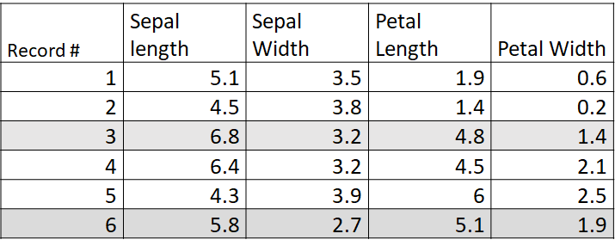
- After the first iteration, which record #s belong to the 1st class and 2nd classes?
Record # 1, 2, 3 and 4 belong to class 1. Record # 5 and 6 belong to class 2.
- At the next iteration, what will be new cluster centers?

Sepal length | Sepal width | Petal Length | Petal Width
5.7 | 3.425 | 3.15 | 1.075 | Cluster center 1
5.05 | 3.3 | 5.55 | 2.2 | Cluster center 2

- At the next iteration, which record #s belongs to the 1st class and 2nd class?
Record # 1, 2, 3 belong to cluster 1
Record # 4, 5, 6 belong to cluster 2

- Marks 3+2+3 = 8

Apply K-Mean Clustering algorithm for following dataset. Assume K=2 and two centres for first iteration are shown in below (shaded rows). Assume initially record # 1 belongs to class 1 and 4th one belongs to class 2.

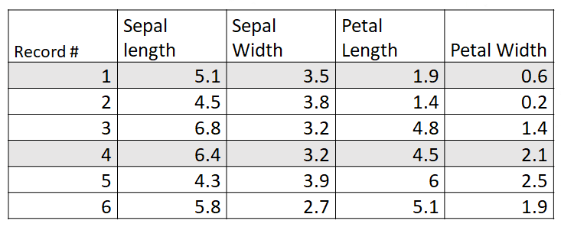

- After the first iteration, which record #s belong to the 1st class and 2nd classes?
Record # 1, 2 belong to class 1. Record # 3, 4, 5 and 6 belong to class 2.
- At the next iteration, what will be new cluster centers?

4.8 | 3.65 | 1.65 | 0.4 | Cluster center #1
5.825 | 3.25 | 5.1 | 1.975 | Cluster center #2

- At the next iteration, which record #s belongs to the 1st class and 2nd class?
Record # 1, 2 belong to class 1. Record # 3, 4, 5 and 6 belong to class 2.

Q.1 Set. (C) Marks 3+2+3=8

Apply K-Mean Clustering algorithm for following dataset. Assume K=2 and two centres for first iteration are shown in below (shaded rows). Assume initially record # 2 belongs to class 1 and 5th one belongs to class 2.

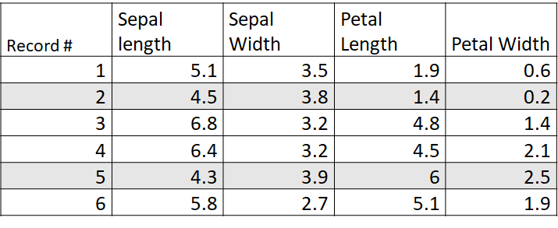

- After the first iteration, which record #s belong to the 1st class and 2nd classes?
Record # 1, 2 belong to class 1. Record # 3, 4, 5 and 6 belong to class 2.
- At the next iteration, what will be new cluster centers?

4.8 | 3.65 | 1.65 | 0.4 | Cluster center #1
5.825 | 3.25 | 5.1 | 1.975 | Cluster center #2

- At the next iteration, which record #s belongs to the 1st class and 2nd class?
Record # 1, 2 belong to class 1. Record # 3, 4, 5 and 6 belong to class 2.

- Marks 1.5+1.5+2+3=8

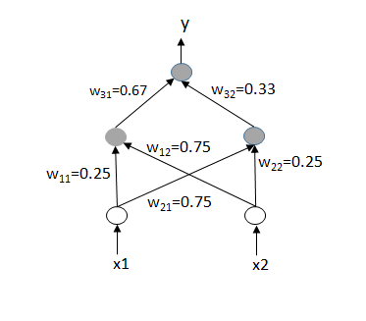
Leaky ReLU activation function is used in the hidden nodes. Leaky ReLU activation function generates output = input, if input >= 0, and 0.1 * input if output < 0. Sigmoid activation function is used in the output node. Assume, squared difference between the actual and target output is used as the loss function, derivative of leaky ReLU activation function = 0 at input = 0, and zero bias at all hidden and output nodes. Learning rate is 0.1. x1=x2=1 and target output=0.

- What is the actual output for the given weights at the current iteration?
o = e/(1+e)
- What is the value of the loss function?
Loss = 0.5*(e/(1+e))²
- What will be the weight w₃₁ in the next iteration?
o = output of output node, net3 = total input to the output node, o1=output of left hidden node
w₃₁=w₃₁-0.1dLoss/do*do/dnet3*dnet3/dw₃₁=0.67-0.1*o*o*(1-o)*1
=0.67-0.1e²/(1+e)²*1/(1+e)=0.67-0.1e²/(1+e)³
- What will be the weight w₁₂ in the next iteration?
w₁₂=w₁₂-0.1dLoss/dnet3*dnet3/do1*do1/w₁₂=0.75-0.1*o*o*(1-o)*w₃₁*1*x2
=0.75 – 0.067e²/(1+e)³

- Marks 1.5+1.5+2+3=8

Leaky ReLU activation function is used in the hidden nodes. Leaky ReLU activation function that generates output = input, if input >= 0, and 0.1 * input if output < 0. Sigmoid activation function is used in the output node. Assume, squared difference between the actual and target output is used as the loss function, derivative of leaky ReLU activation function = 0 at input = 0, and zero bias at all hidden and output nodes. Learning rate is 0.1. x1=x2=0 and target output=1.

- What is the actual output for the given weights at the current iteration?
Output y = 0.5
- What is the value of the loss function?
Loss = 0.5*0.5² = 0.125
- What will be the weight w₃₂ in the next iteration?
Δw₃₂= -0.1*δLoss/δw₃₂ = -0.1*δLoss/δy* δy/δnet₃ * δnet₃/δw₃₂
= -0.1*δLoss/δy* δy/δnet₃*o₂ = 0
w₃₂=0.33
- What will be the weight w₂₂ in the next iteration?
Δw₂₂= -0.1*δLoss/δw₂₂ = -0.1*δLoss/δnet₃ * δnet₃/δo₂ * δo₂/δnet₂ * δnet₂/δw₂₂
= -0.1* δLoss/δnet₃ * δnet₃/δo₂ * 0 * 0 = 0
w₂₂=0.25

Q.2 Set. (C) Marks 1.5+1.5+2+3=8

Leaky ReLU activation function is used in the hidden nodes. Leaky ReLU activation function that generates output = input, if input >= 0, and 0.1 * input if output < 0. Sigmoid activation function is used in the output node. Assume, squared difference between the actual and target output is used as the loss function, derivative of leaky ReLU activation function = 0 at input = 0, and zero bias at all hidden and output nodes. Learning rate is 0.1. x1=1, x2=0 and target output=0.

- What is the actual output for the given weights at the current iteration?
y= 1/(1+exp(-0.67*0.25-0.33*0.75))=0.6023
- What is the value of the loss function?
Loss=0.5*(0.6023-0)²=0.1814
- What will be the weight w₃₁ in the next iteration with standard gradient descent?
w₃₁=0.67-0.1δLoss/δw₃₁=0.67-0.1*0.6023*0.6023* (1-0.0.6023)*0.25=0.6664
- What will be the weight w₁₁ in the next iteration with standard gradient descent?
w₁₁=0.25-0.1δLoss/δw₁₁=0.25-0.1*0.6023*0.6023* (1-0.6023)*0.67=0.2403

- 1+1+2+2+1+1=8 Marks

Consider training an AdaBoost classifier using decision stumps on the following data set. Decision stump classifier chooses a constant value c and classifies all points where x > c as one class and other points where x ≤ c as the other class.
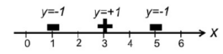

- What is the initial weight that is assigned to each data point? 1/3, 1/3, 1/3

- Show the decision boundary for the first decision stump (indicate the positive and negative side of the decision boundary).
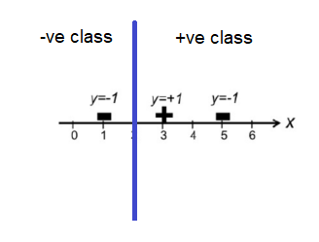
Note: Multiple valid solutions exist.

- Calculate the importance of the first decision stump.
Data at x=5 is misclassified. So,
Error rate Ԑ₁= 1/3*1/3=1/9
Importance α₁ = 0.5 ln((1- Ԑ₁ ) / Ԑ₁) = 0.5ln(8)

- Calculate the weights for the next iteration increases in the boosting process
w1 = 1/3 * exp(-0.5ln(8)) / Z , corresponding to data @ x=1
w2 = 1/3 * exp(-0.5ln(8)) / Z , corresponding to data @ x=3
w3 = 1/3 * exp(0.5ln(8)) / Z , corresponding to data @ x=5
Z = 1/3 * (2 exp(-0.5ln(8))+ exp(0.5ln(8))

- How does bagging process in random forest technique impact variance?
Reduces variance
- How does feature randomization process in random forest technique impact bias?
Reduces bias

- 1+1+2+2+1+1=8 Marks

Consider training an AdaBoost classifier using decision stumps on the following data set. Decision stump classifier chooses a constant value c and classifies all points where x > c as one class and other points where x ≤ c as the other class.

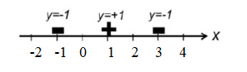
- What is the initial weight that is assigned to each data point? 1/3, 1/3, 1/3
- Show the decision boundary for the first decision stump (indicate the positive and negative side of the decision boundary).

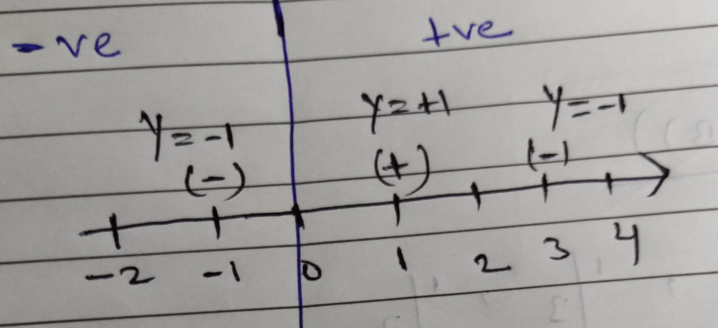

- Calculate the importance of the first decision stump.

Data at x=3 is misclassified. So,
Error rate Ԑ1= 1/3*1/3=1/9
Importance α1 = 0.5 ln((1- Ԑ1 ) / Ԑ1) = 0.5ln(8)

- Calculate the weights for the next iteration increases in the boosting process.
w1 = 1/3 * exp(-0.5ln(8)) / Z , corresponding to data @ x=-1
w2 = 1/3 * exp(-0.5ln(8)) / Z , corresponding to data @ x=1
w3 = 1/3 * exp(0.5ln(8)) / Z , corresponding to data @ x=3
Z = 1/3 * (2 exp(-0.5ln(8))+ exp(0.5ln(8))
- How does bagging process in random forest technique impact variance?

It reduces variance
- How does feature randomization process in random forest technique impact bias?

It reduces bias

Q.3 Set. (C) 1+1+2+2+1+1=8 Marks

Consider training an AdaBoost classifier using decision stumps on the following data set. Decision stump classifier chooses a constant value c and classifies all points where x > c as one class and other points where x ≤ c as the other class.

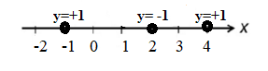
- What is the initial weight that is assigned to each data point?1/3, 1/3, 1/3
- Show the decision boundary for the first decision stump (indicate the positive and negative side of the decision boundary).

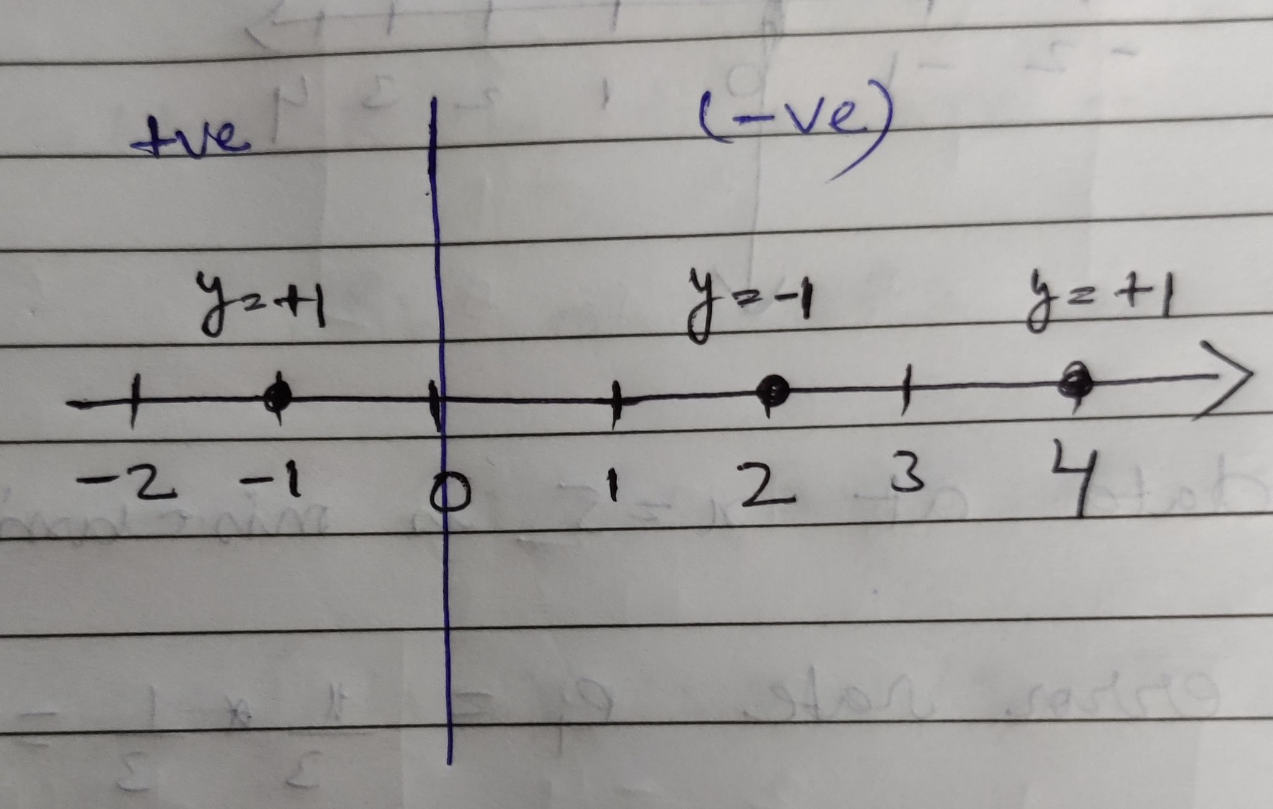
- Calculate the importance of the first decision stump.

Data at x=4 is misclassified. So,
Error rate Ԑ1= 1/3*1/3=1/9
Importance α1 = 0.5 ln((1- Ԑ1 ) / Ԑ1) = 0.5ln(8)

- (D)Calculate the weights for the next iteration increases in the boosting process
w1 = 1/3 * exp(-0.5ln(8)) / Z , corresponding to data @ x= -1
w2 = 1/3 * exp(-0.5ln(8)) / Z , corresponding to data @ x=2
w3 = 1/3 * exp(0.5ln(8)) / Z , corresponding to data @ x=4
Z = 1/3 * (2 exp(-0.5ln(8))+ exp(0.5ln(8))
- (E)How does bagging process in random forest technique impact variance?
It reduces variance
- (F)How does feature randomization process in random forest technique impact bias?
It reduces bias

- 3+2+3=8 marks

Consider the following data

Input x | Output y
0 | 0
1 | 1
2 | 5
4 | 15

- Determine the best parameters of the regression model given by output = w0+w1*x² + w2*x³.
1 0 0
1 1 1
1 4 8
1 16 64
0
1
5
15
w0
w1
w2
=

[w0 w1 w2] = [-0.16957 1.58773 -0.15978]

- Assume learning rate α=0.5. At iteration t, w0=2, w1=1 and w2=0. What will be the values of w0, w1 and w2 at next iteration t+1?
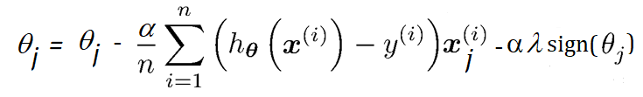

Input x | Output y | x₁=x² | x₂=x³ | h_{ɵ}(x)=w0+w1x₁+w2x₂
0 | 0 | 0 | 0 | 2
1 | 1 | 1 | 1 | 3
2 | 5 | 4 | 8 | 6
4 | 15 | 16 | 64 | 18

w0 = 2 – 0.5/4 [2+2+1+3]=1
w1=1-0.5/4[2*0+2*1+1*4+3*16] = -5.75
w2=0-0.5/4[2*0+2*1+1*8+3*64]= -25.25

- Assume L1 regularization with regularization constant λ=1 and learning rate α=0.5. At iteration t, w0=2, w1=1 and w2=0. What will be the values of w0, w1 and w2 at the next iteration t+1? Assume zero is a positive integer.
w0=1, no regularization applied
w1=-5.75-0.5=-6.25
w2=-25.25-0.5=-25.75

- 3+2+3=8 Marks

Consider the following data

Input x | Output y
0 | 0
1 | 1
2 | 10
4 | 60

- Determine the best parameters of the regression model given by output = w0+w1*x + w2*x³.

[w0 w1 w2] = [-0.41 1.51 0.85]

- Assume learning rate α=0.5. At iteration t, w0=2, w1=0 and w2=1. What will be the values of w0, w1 and w2 at next iteration t+1?
Input x | Output y | x₁=x | x₂=x³ | h_{ɵ}(x)=w0+w1x₁+w2x₂
0 | 0 | 0 | 0 | 2
1 | 1 | 1 | 1 | 3
2 | 10 | 2 | 8 | 10
4 | 60 | 4 | 64 | 66

w0 = 2 – 0.5/4 [2+2+0+6] = 1.875 w1=0-0.5/4[2*0+2*1+0*2+6*4] = -3.25
w2=1-0.5/4[2*0+2*1+0*8+6*64] = -47.25
- Assume L1 regularization with regularization constant λ=1 and learning rate α=0.5. At iteration t, w0=2, w1=0 and w2=1. What will be the values of w0, w1 and w2 at next iteration t+1? Assume zero is a positive integer.
w0=1.875, no regularization applied
w1=-3.25-0.5=-3.75
w2=-47.25-0.5=-47.75

- 2+4+2 = 8 Marks

Consider the following data

Input x | Output y
0 | 0
1 | 1
2 | 3
4 | 3

- Determine the best parameters of the regression model given by output = w0+w1*x + w2*x².
[w0 w1 w2] = [-0.191 1.995 -0.295]

- Assume learning rate α=0.5. At iteration t, w0=2, w1=1 and w2=0. What will be the values of w0, w1 and w2 at next iteration t+1?
Input x | Output y | x₁=x | x₂=x² | h_{ɵ}(x)=w0+w1x₁+w2x₂
0 | 0 | 0 | 0 | 2
1 | 1 | 1 | 1 | 3
2 | 3 | 2 | 4 | 4
4 | 3 | 4 | 16 | 6
w0 = 2 – 0.5/4 [2+2+1+3] = 1
w1=1-0.5/4[2*0+2*1+1*2+3*4] = -1
w2=0-0.5/4[2*0+2*1+1*4+3*16] = -6.75
- Assume L1 regularization with regularization constant λ=1 and learning rate α=0.5. At iteration t, w0=2, w1=1 and w2=0. What will be the values of w0, w1 and w2 at next iteration t+1? Assume zero is a positive integer.

w0=1, no regularization applied
w1=-1-0.5=-1.5
w2=-6.75-0.5=-7.25

- 3+1+2+2=8 Marks

Training data is represented by the following matrix A, whose rows corresponding to training records and columns corresponding to input dimensions.

2 0
-3 1
1 -3
0 2
A =

- What is the best possible projection of this data in one-dimension that minimizes the loss of information?

Covariance matrix = A’*A (note: A is zero mean)
Eigenvector of A’*A corresponding to largest eigenvalue=20 is e1 = [-0.707 0.707]
Best possible projection: A*e1’= [-1.4142 2.8284 -2.8284 1.4142]’

- Show the 3x3 convolution kernel for implementing mean pooling in gray scale images.

[1/9 1/9 1/9; 1/9 1/9 1/9; 1/9 1/9 1/9]

Consider an LSTM network with one hidden layer of 20 nodes used for sentiment prediction of the following data. No bias is used in any of the nodes. One-hot representation is used for representing the input and output.

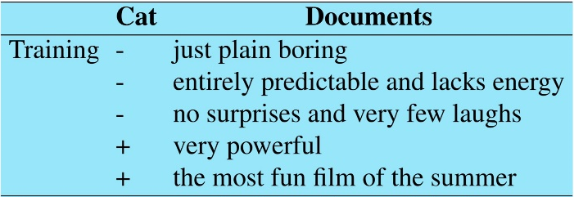

- How many input and output nodes will be needed in the LSTM network? Assume each training data starts with a <SOS> and ends with a <EOS> token.
Number of Unique words = 21. So, # of input nodes = 21+2=23, including the <SOS> and <EOS> tokens
# of output nodes = 2

- What will be the total number of trainable weights in the LSTM network? (Show individual numbers for all LSTM components for partial marking)
4*(23+20)*20+20*2
- 3+2+1+2=8 Marks

Training data is represented by the following matrix A, whose rows corresponding to training records and columns corresponding to input dimensions.

2 0
-2 1
1 -3
-1 2
A =

- What is the best possible projection of this data in one-dimension that minimizes the loss of information?

P= [-1.2044 2.0027 -2.9972 2.1989]’

- What is that minimum value of total loss over the training data?

||A-P*e1’||=2.1725

- Show the 5x5 convolution kernel for implementing mean pooling in a gray scale image.
[1/25 1/25 1/25 1/25 1/25; 1/25 1/25 1/25 1/25 1/25; 1/25 1/25 1/25 1/25 1/25]

Consider the following inception blocks in a hypothetical GoogLeNet architecture.
- What is the size of the output post concatenation of the channels?
28x28x248
- What is the total number of trainable parameters? Assume no bias is used.
100*96+100*16+96*3*3*184+16*5*5*64

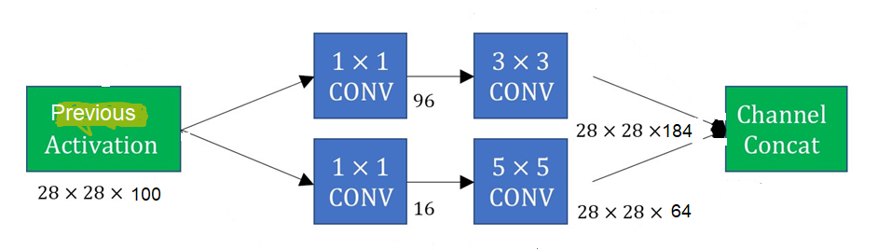

- 3+3+2=8 Marks

Training data is represented by the following matrix A, whose rows corresponding to training records and columns corresponding to input dimensions.

2 0
-3 2
1 -1
0 -1
A =

- What is the best possible projection of this data in one-dimension that minimizes the loss of information?

Covariance matrix = A’*A (note: A is zero mean)
Eigenvector of A’*A corresponding to largest eigenvalue=18.1 is e1 = [-0.865 0.502]
Best possible projection: A*e1’= [-1.72982 3.59858 -1.36684 -0.50193]’

Consider a vanilla RNN network with one hidden layer of 10 nodes used for sentiment prediction of the following data. One-hot representation is used for representing the input and output.

- How many input and output nodes will be needed in the RNN network? Assume each training data starts with a <SOS> and ends with a <EOS> token.
Number of Unique words = 21. So, # of input nodes = 21+2=23, including the <SOS> and <EOS> tokens
# of output nodes = 2

- What will be the total number of trainable parameters (including bias) in the RNN network? (Show individual numbers for all RNN components for partial marking)
(23+10)*10 + 10*2 + 10+2
Consider the following inception blocks in a hypothetical GoogLeNet architecture.
- What is the size of the output post concatenation of the channels?
28x28x220 = 172480
- What is the total number of trainable parameters? Assume no bias is used.
100*64 + 100*32 + 64*3*3*92 + 32*5*5*128 = 164992

